Labour Day 2nd May 2025
Celebrating the spirit of hard work and determination.
We discussed so many professions a day before celebrating it and we prepare children for the roleplay on different profession. Students gain the knowledge about the importance of different professions and also discussed about their goal and favorite profession.
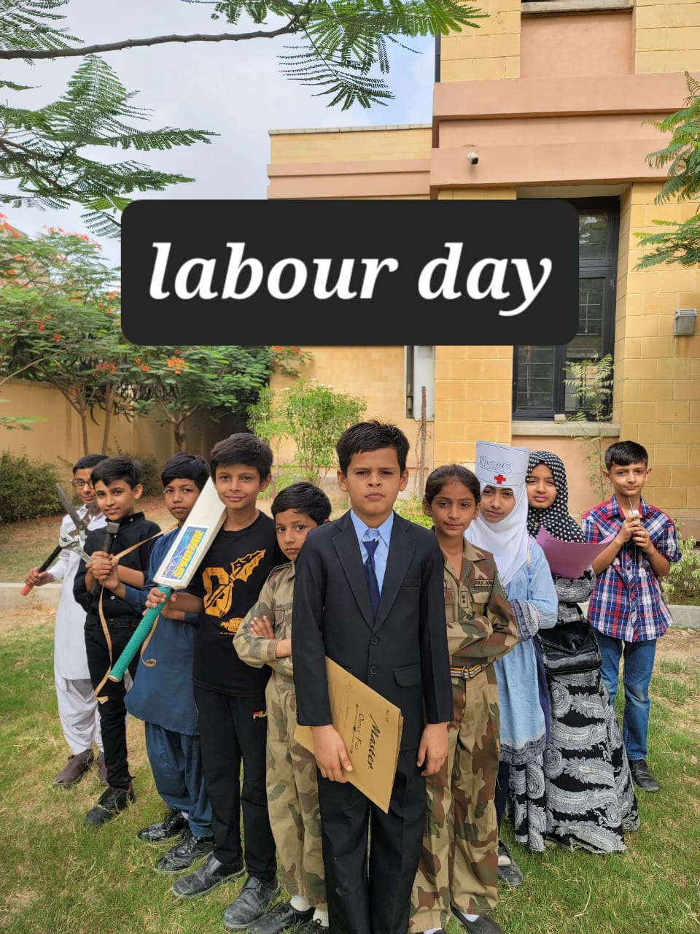


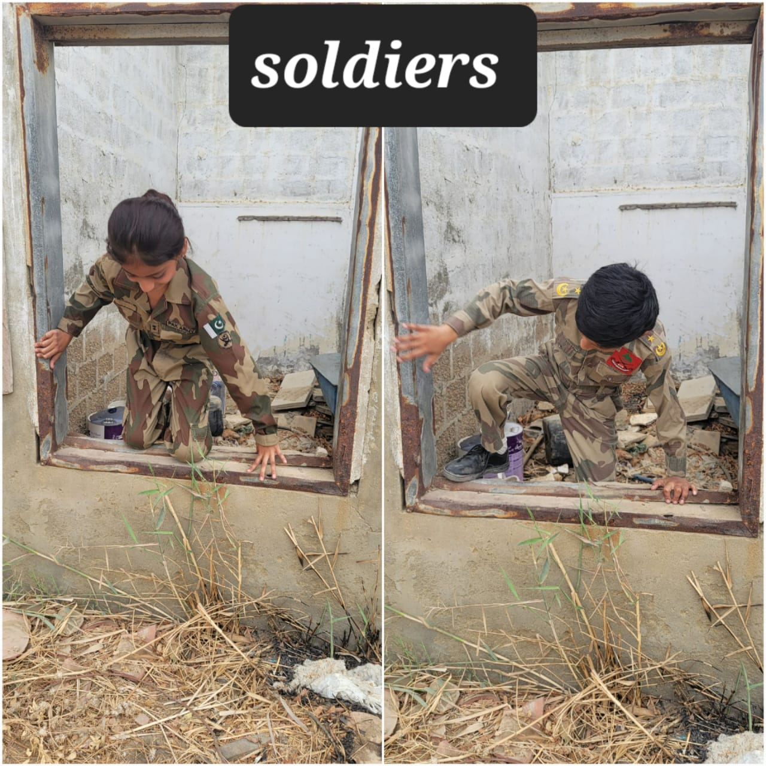
Mother’s Day 12th May 2025
To the women who turns then obstacles into opportunities, you’re my biggest role model My Mother.
we celebrated this activity to honor Mothers. We taught them the importance of Mothers, gratitude and appreciation for their mothers. Students were also encouraging to make cards.
These activities help students develop a deeper understanding of the importance of mothers and encourage them to show appreciation for their own mothers.
